

**School:** *School of Education, Social Sciences and Technology*

**Degree Programme:** *Bachelors of Information Technology*

**Course:** **BIT 324 –SYSTEM DESIGN AND IMPLEMENTATION ASSIGNMENT**

**No. 1**

**NAME: MSWATI ROY DAKA**

**STUDENT NUMBER: BIT17211051**

**YEAR OF STUDY: THIRD**

**SEMESTER: SECOND**

**UNILUS** Pioneer Campus

P.O. Box 36711

**LUSAKA.**

**Physical Address:**

UNILUS

Plot No. 37413, Off Alick Nkhata Road (Behind Alliance Francaise), Mass Media,

**LUSAKA.**

**DOCUMENTATION**

**INTRODUCTION**

**CHARLOTTE’S WEB,** is a web-based Jewellery store. The web application provides a platform on which individuals can explore different spider themed jewellery. The application doesn’t allow users to purchase but gives them access to create appointments that are best suited for them. Upon scheduling appointments, the users can meet with the staff and create custom designs. Before scheduling an appointment, the user is also free to look at past works by the store.

The aim of the application is to provide accessibility to individuals who may live far from the physical location. The app also makes it convenient by providing a wide range of options giving an idea of what to expect to users.

**Requirements**

The system will have a user access the services on an installed application software and an internet connection. So generally, any individual with access to a smartphone device connected to the internet can access the application, of course only if they meet the minimum requirements. So the requirements are as follows:

* A device capable of accessing the internet
* An internet connection
* The necessary information to schedule an appointment
* The device should run on android 7.1 and above or iOS 9.

**User and Process Documentation**

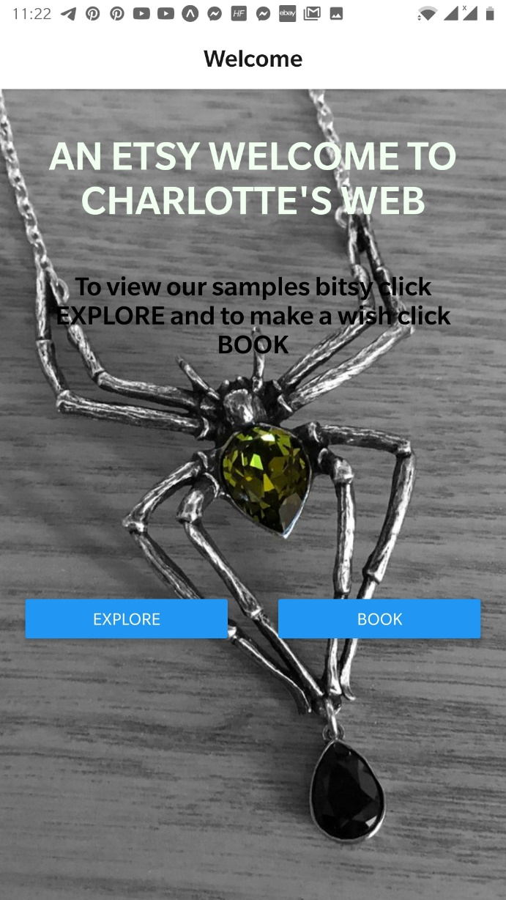

Fig 1.0

Fig 1.0 shows the Welcome screen of the application. It provides the users with two options which are to either **EXPLORE** or **BOOK**

**EXPLORE**: this option takes the user to the next screen which is the Home Screen on which a user can view different works done by the store.

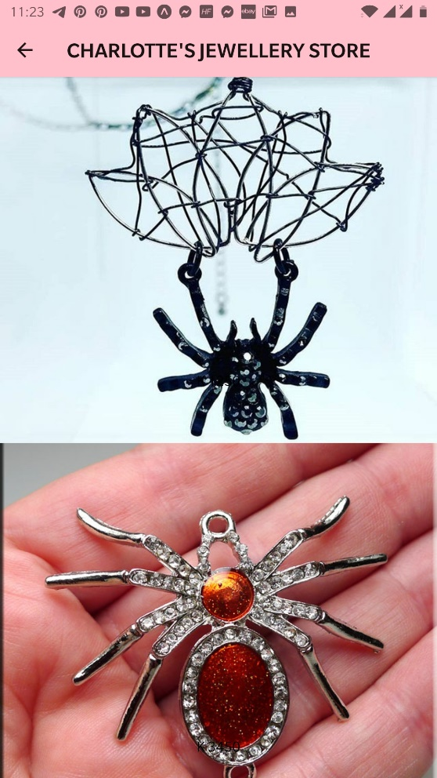s

Fig 2.0

Upon clicking on any of the items an individual opens the Appointment page which can also be accessed by clicking **BOOK** on the home screen.

**System Development**

CHARLOTTE’S WEB is mainly developed in REACT NATIVE, with the use of:

* JAVA SCRIPT: is an object-oriented language that is used in the logic and user interface of web and mobile application. React Native is based on Java Script which is also a scripting language.
* Cascading Style Sheets (CSS): Cascading Style Sheets is a style sheet language used for describing the presentation of a document written in a markup language

The combination of the above languages led to the development of CHARLOTTE’S WEB.

The development process employed the use of the software listed below

* Visual Studio Code: this is a general-purpose text editor. This was used to write the JavaScript and the CSS.
* EXPO: expo is a tool built around REACT NATIVE that allows for the testing of mobile applications and quickly starting them without having to install them.

**Data Flow**

The flow of data is accompanied by very easy steps. The user is welcomed by the welcome screen where he or she has the option to either explore past works or directly to the appointment page on which he or she can schedule an appointment.

**Source Code**

* Welcome Screen

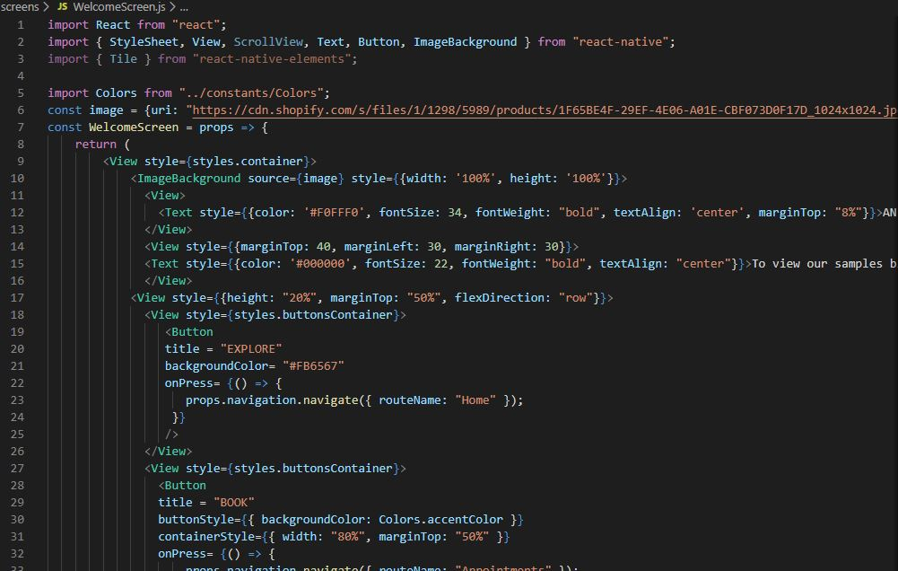

Fig 4.0

Shows the code of the explore and book button for any individual looking to access the services on the site.

* Home Screen

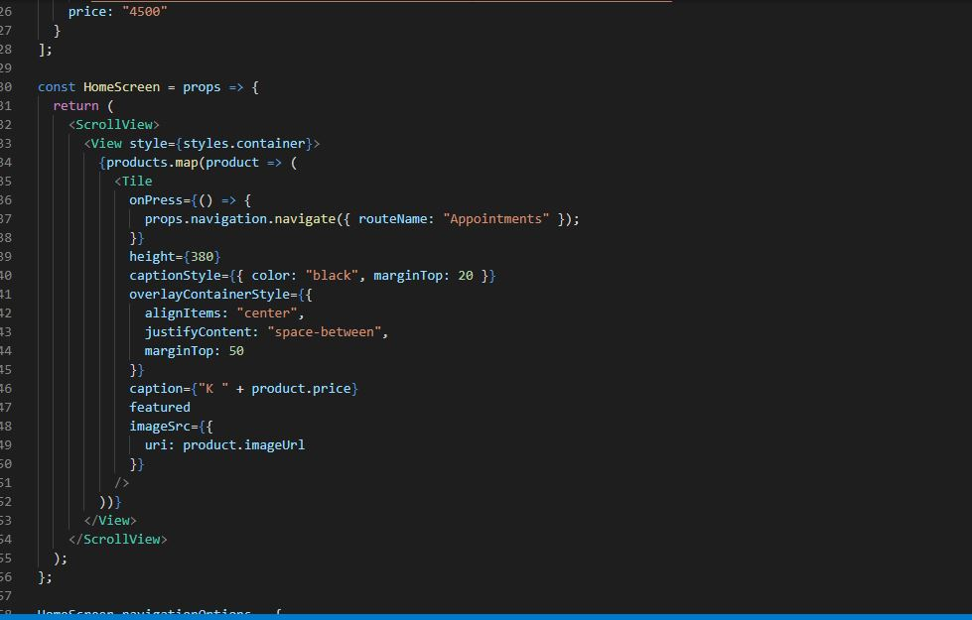

Fig 5.0

This fig shows the code that allows user to view different pieces of work.

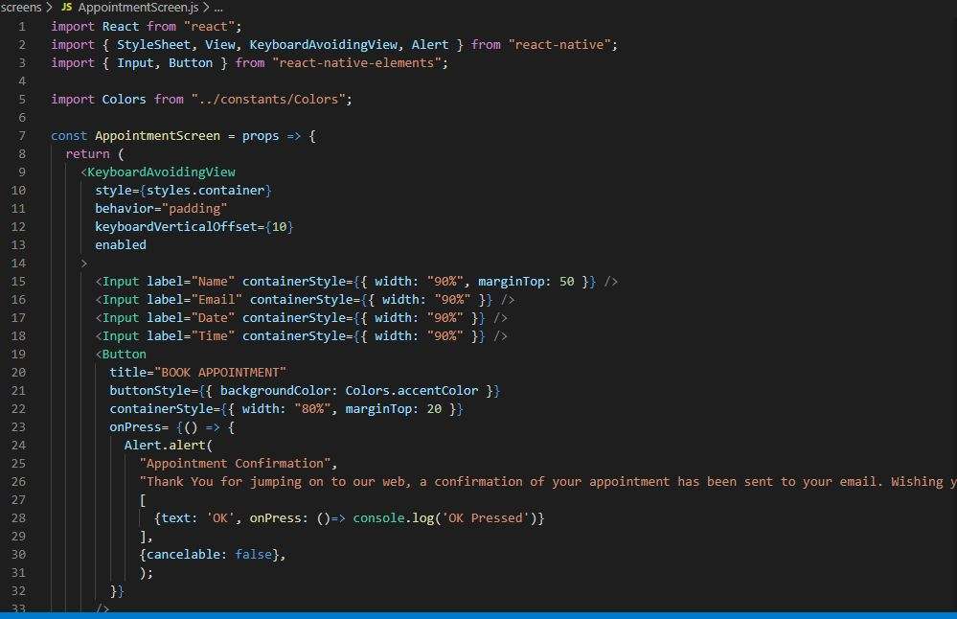

Fig 6.0

This segment of code shows how the user can schedule an appointment and how he gets a confirmation of the appointment.

**Design Approach**

An agile oriented method was used to design the application. Being an object-oriented language, it allowed the freedom to work on different components of the code without completion of others.